In this challenge we ask you to create a single page application with two views (profile and contact us). Even though this is a tiny react app where you normally wouldn’t use redux, assume that this is part of a much larger project.

Here are a few pointers to what we will judge you on:

1. Use of react
2. Use of redux to manage state of the app
3. How accurately is the design translated from design to web site
4. UI internationalization (implement at least one more language of your choice)
5. Responsiveness of the website.

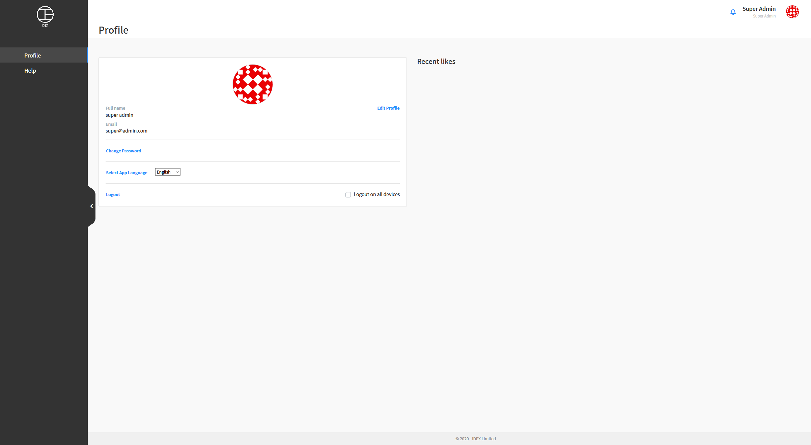

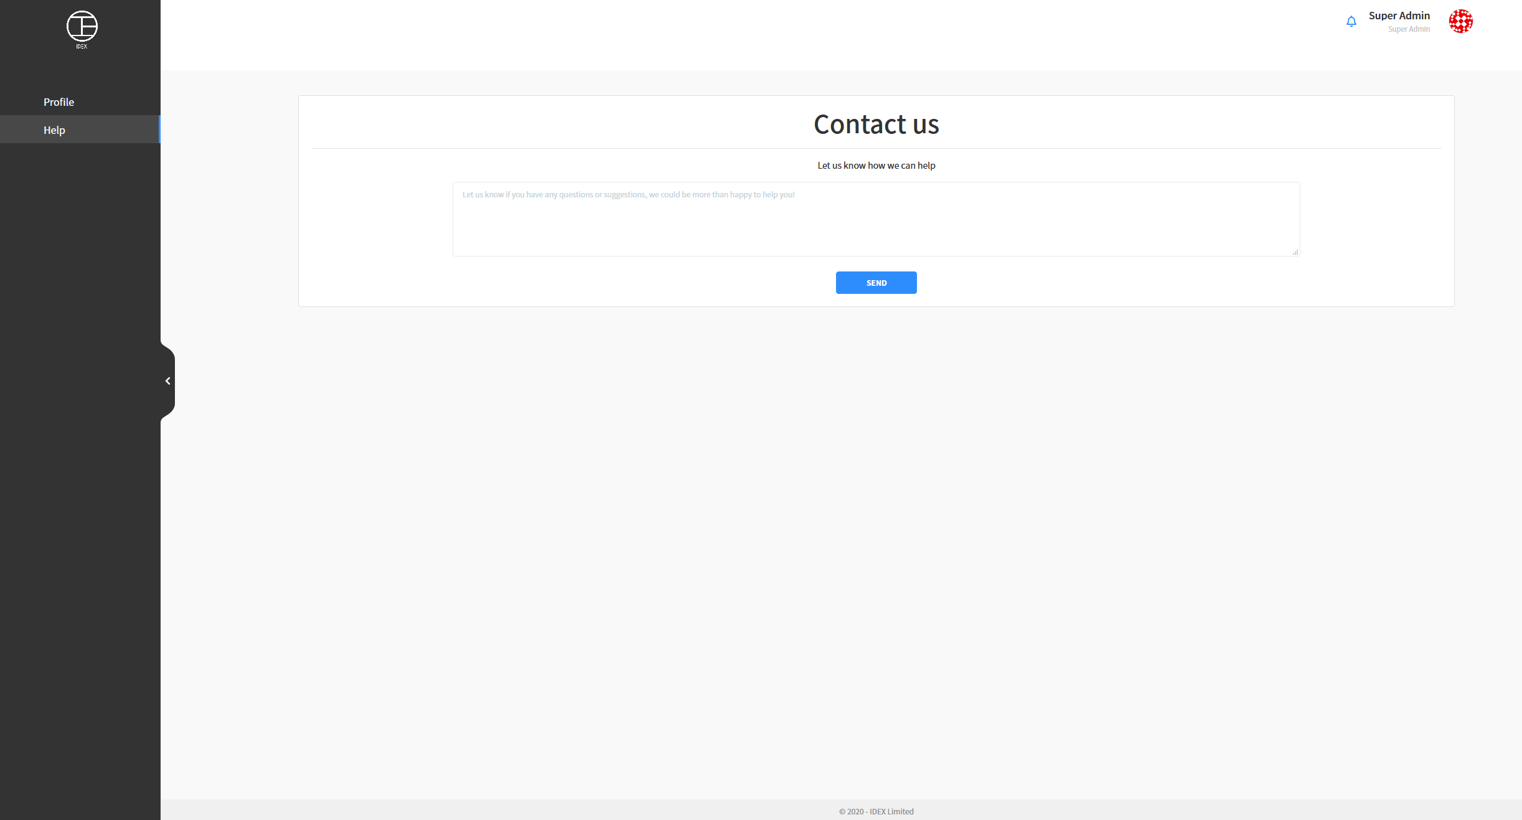

You shouldn’t spend more than 90mins on this challenge and you have to upload your work for instance to Netlify and send us the source code (in a zip file or link to GitHub) in no more than 2hrs from the time you received this email. Goes without saying that the source code and web version need to match.

However if you have still spare time left, go ahead and surprise us. Like making it possible to upload/change the profile picture or implement validation of the input fields, which will display errors in the language the user selected (the second language you implemented)

Good luck, we are looking forward to seeing what you can do.